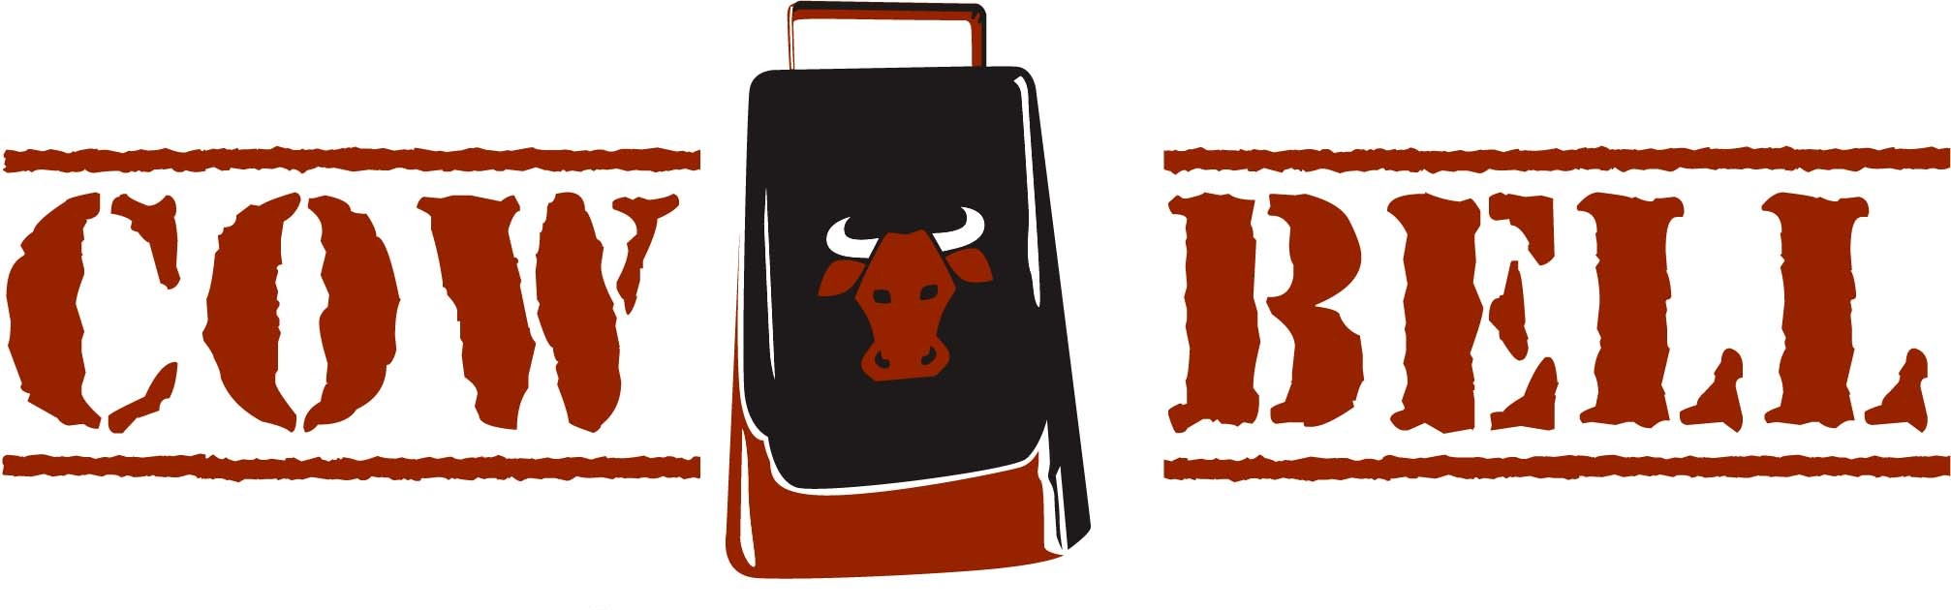 | CALENDAR- ROCK ROW: OCTOBER 2025  ALL SPORTS MONTH: NFL, MLB PLAYOFFS, NBA, NHL

SUNDAY | MONDAY | TUESDAY | WEDNESDAY | THURSDAY | FRIDAY | SATURDAY
  BOOK YOUR PARTY HERE! |   MON-FRI  3pm-6pm |  | 1  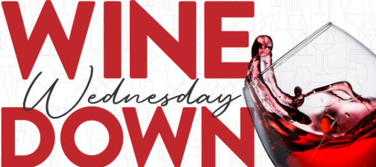  wednesday  25% off Bottles | 2  WHISKEY NIGHT  25% OFF WHISKEY  DON CORMAN  TRIVIA & GAMES | 3    LIVE MUSIC SERIES  Jeff BYRD  530pm | 4  SPORTS SATURDAY  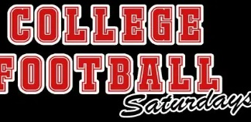
5 PATS/BILLS 8pm   SUNDAY BUCKETS  BUCKET SPECIALS  WATCH ALL GAMES HERE | 6 MONDAY  $6 MARGARITAS  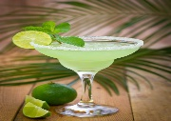 | 7    630 pm | 8 BRUINS OPENER  wednesday  25% off Bottles | 9  WHISKEY NIGHT  25% OFF WHISKEY  DON CORMAN  TRIVIA & GAMES | 10  LIVE MUSIC SERIES  Kris hype  530pm | 11  SPORTS SATURDAY  SPORTS ACTION ALL DAY!
12 PATS/SAINTS 4pm  SUNDAY BUCKETS  BUCKET SPECIALS  WATCH ALL GAMES HERE | 13 MONDAY  $6 MARGARITAS | 14  630 pm | 15  wednesday  25% off Bottles | 16  WHISKEY NIGHT  25% OFF WHISKEY  DON CORMAN  TRIVIA & GAMES | 17    LIVE MUSIC SERIES  Chris james  530pm | 18  SPORTS SATURDAY  SPORTS ACTION ALL DAY!
19 PATS/TITANS 1pm  SUNDAY BUCKETS  BUCKET SPECIALS  WATCH ALL GAMES HERE | 20 MONDAY  $6 MARGARITAS | 21  630 pm | 22 CELTICS OPENER  wednesday  25% off Bottles | 23  WHISKEY NIGHT  25% OFF WHISKEY  DON CORMAN  TRIVIA & GAMES | 24  LIVE MUSIC SERIES  GRACI GILLEN  530pm | 25 SPORTS SATURDAY  SPORTS ACTION ALL DAY!
26 PATS/BROWNS 1pm  SUNDAY BUCKETS  BUCKET SPECIALS  WATCH ALL GAMES HERE | 27 MONDAY  $6 MARGARITAS | 28  630 pm | 29  wednesday  25% off Bottles | 30  WHISKEY NIGHT  25% OFF WHISKEY  DON CORMAN  TRIVIA & GAMES | 31  HAPPY HALLOWEEN!  WORLD SERIES  CELTICS  NO MUSIC TONIGHT! | 