JANUARY : ENTERTAINMENT CALENDAR
FEATURE of the Month: “THE ANIMAL BURGER”
1  ALL DAY HAPPY HOUR  PATS/MIA 1pm | 2  BOWL GAMES | 3 WINE & DINE!  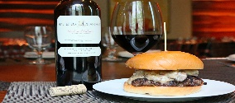  $20 Bottles of Wine | 4  $5 MAINE CRAFTS  $7 MAINE LIQUOR | 5  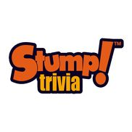  THURS. $5 TAPS  Drinking w Lincoln | 6  $5 FOOD/BEERS  Cole downing  6 pm | 7  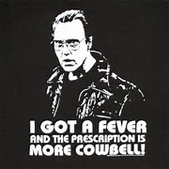  EAT MORE  COWBELL!
8  ALL DAY HAPPY HOUR  PATS/BUF | 9  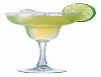  Margarita  Monday | 10 WINE & DINE!  $20 Bottles of Wine | 11  $5 MAINE CRAFTS  $7 MAINE LIQUOR | 12  THURS. $5 TAPS  Drinking w Lincoln | 13  $5 FOOD/BEERS  Emily torres  6 pm | 14  EAT MORE  COWBELL!
15  ALL DAY HAPPY HOUR  NFL WILDCARD  WEEKEND | 16  Margarita  Monday | 17 WINE & DINE!  $20 Bottles of Wine | 18  $5 MAINE CRAFTS  $7 MAINE LIQUOR | 19  THURS. $5 TAPS  Drinking w Lincoln | 20  $5 FOOD/BEERS  Justin carver  6 pm | 21  EAT MORE  COWBELL!
22  ALL DAY HAPPY HOUR  NFL PLAYOFFS | 23  Margarita  Monday | 24 WINE & DINE!  $20 Bottles of Wine | 25  $5 MAINE CRAFTS  $7 MAINE LIQUOR | 26  THURS. $5 TAPS  Drinking w Lincoln | 27  $5 FOOD/BEERS  JAY LARKIN  6 pm | 28  EAT MORE  COWBELL!
29  ALL DAY HAPPY HOUR  NFL CONFERENCE  CHAMPIONSHIPS | 30  Margarita  Monday | 31  WINE & DINE!  $20 Bottles of Wine | $5 MAINE CRAFTS  $7 MAINE LIQUOR | THURS. $5 TAPS  Drinking w Lincoln | $5 FOOD/BEERS | COMING FEB 4  Comedy Show

