 | SCARBOROUGH: DEC 2025 CHILLI MONTH SPECIALS  AREAS BEST HAPPY HOUR: Mon-Fri 3pm-6pm $5 SELECT Crafts & FOOD
SUNDAY | MONDAY | TUESDAY | WEDNESDAY | THURSDAY | FRIDAY | SATURDAY
 | 1 MONDAY  $6 MARGARITAS 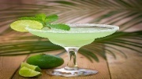  ½ PRICE TACOS  6pm-cl | 2    $5 LADIES WINE | 3    6pm  SAM /SURFSIDE SPEC | 4  TALLS FOR SMALLS | 5    $5 BEERS  FRIDAY KARAOKE | 6  SPORTS SATURDAY  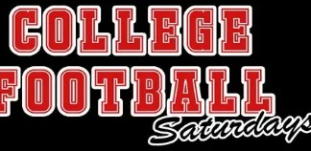
7 NFL GAMES   SUNDAY BUCKETS  BUCKET SPECIALS | 3 MONDAY  $6 MARGARITAS  ½ PRICE TACOS  6pm-cl | 9  $5 LADIES WINE | 10  6pm  SAM /SURFSIDE SPEC | 11  TALLS FOR SMALLS | 12  $5 BEERS  FRIDAY KARAOKE | 13  SPORTS SATURDAY  ARMY /NAVY GAME
14 *PATS/BILLS 1pm  SUNDAY BUCKETS  BUCKET SPECIALS | 15 MONDAY  $6 MARGARITAS 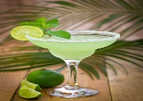  ½ PRICE TACOS  6pm-cl | 16  $5 LADIES WINE | 17    6pm  SAM /SURFSIDE SPEC | 18  TALLS FOR SMALLS | 19    $5 BEERS  FRIDAY KARAOKE | 20  SPORTS SATURDAY
21 PATS/RAVENS 1pm  SUNDAY BUCKETS  BUCKET SPECIALS | 22 MONDAY  $6 MARGARITAS  ½ PRICE TACOS  6pm-cl | 23  $5 LADIES WINE | 24  CHRISTMAS EVE  CLOSED 4pm | 25    CLOSED FOR  CHRISTMAS | 26    $5 BEERS  FRIDAY KARAOKE | 27  SPORTS SATURDAY  
28 PATS/JETS 1pm  SUNDAY BUCKETS  BUCKET SPECIALS | 29  $6 MARGARITAS  ½ PRICE TACOS  6pm-cl | 30  $5 LADIES WINE | 31  6pm  SAM /SURFSIDE  SPECIALS |  |   MON-FRI 3-6p  $5 SELECT BEERS  $5 FOOD SPEC.

